Single Page Personal Portfolio Websites

Site 1: <https://janlosert.com/>

Features: Only two links on what could be considered the navigation bar ( My Products & Contact). There is a link to download pdf version of his CV

Layouts: Multiple sections dividing up the various types of projects or products that that he has worked on. On centered on page and scrollable. Several External links to the live websites. Page is not overwhelming or and easily scrollable.

Styles: The site features a minimalist approach using a white background with either black or gold text. A very simple-minimalist font which makes reading very easy.

Functionality: Plenty of links to provide supplemental information on any of the projects he is describing or view recent projects that are hosted on Dribble and Behance. Easily purchase UI kits made.

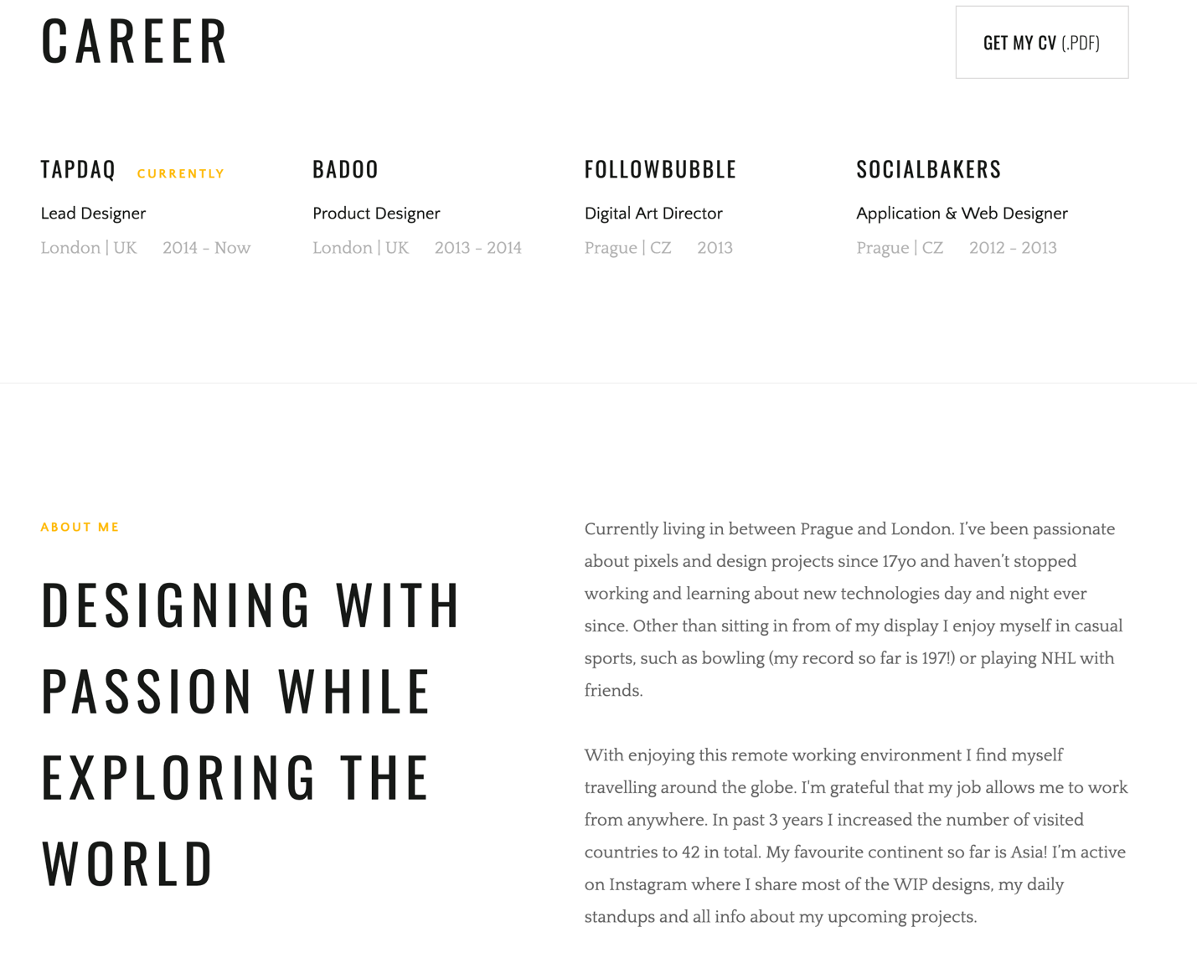

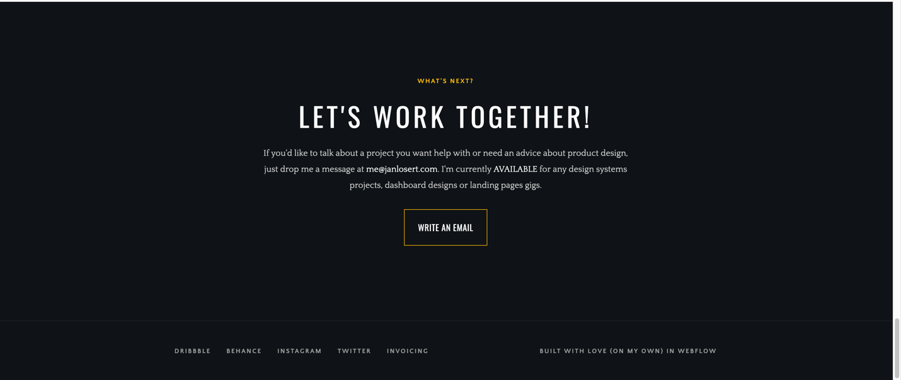

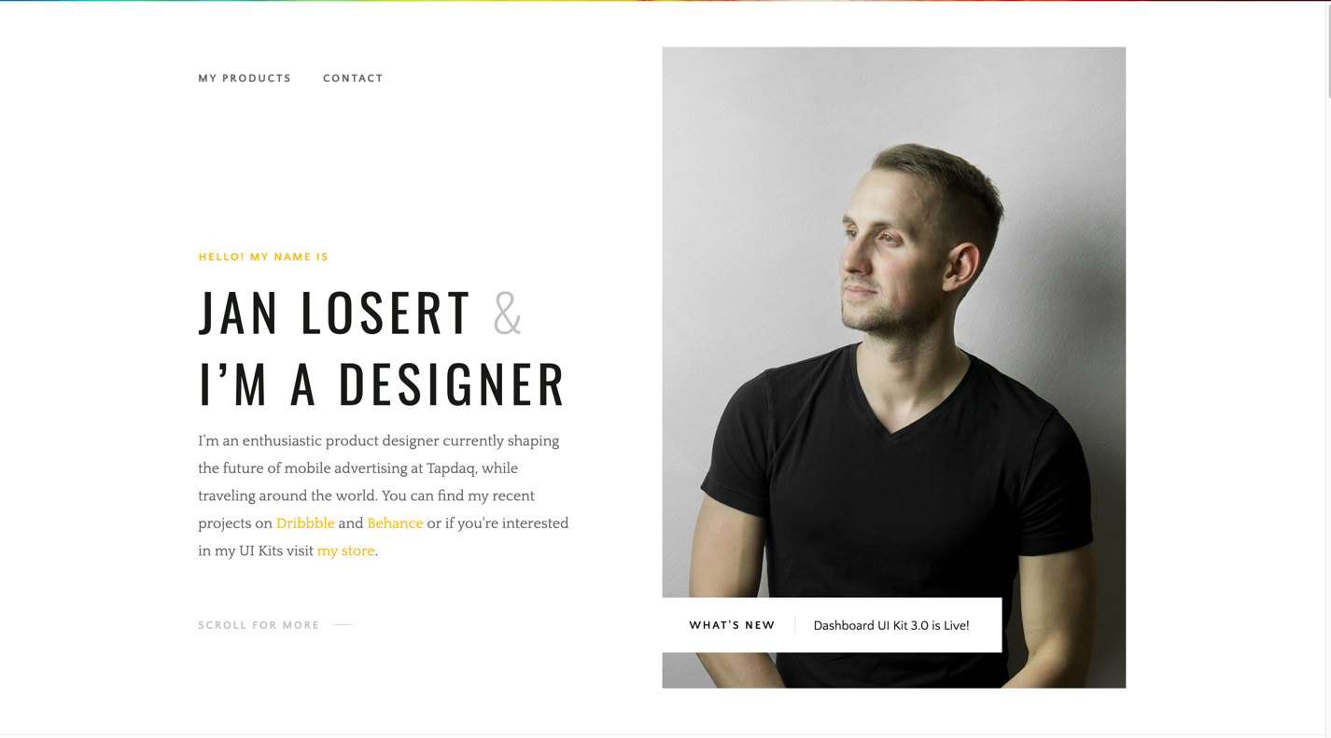

Responsive Design:

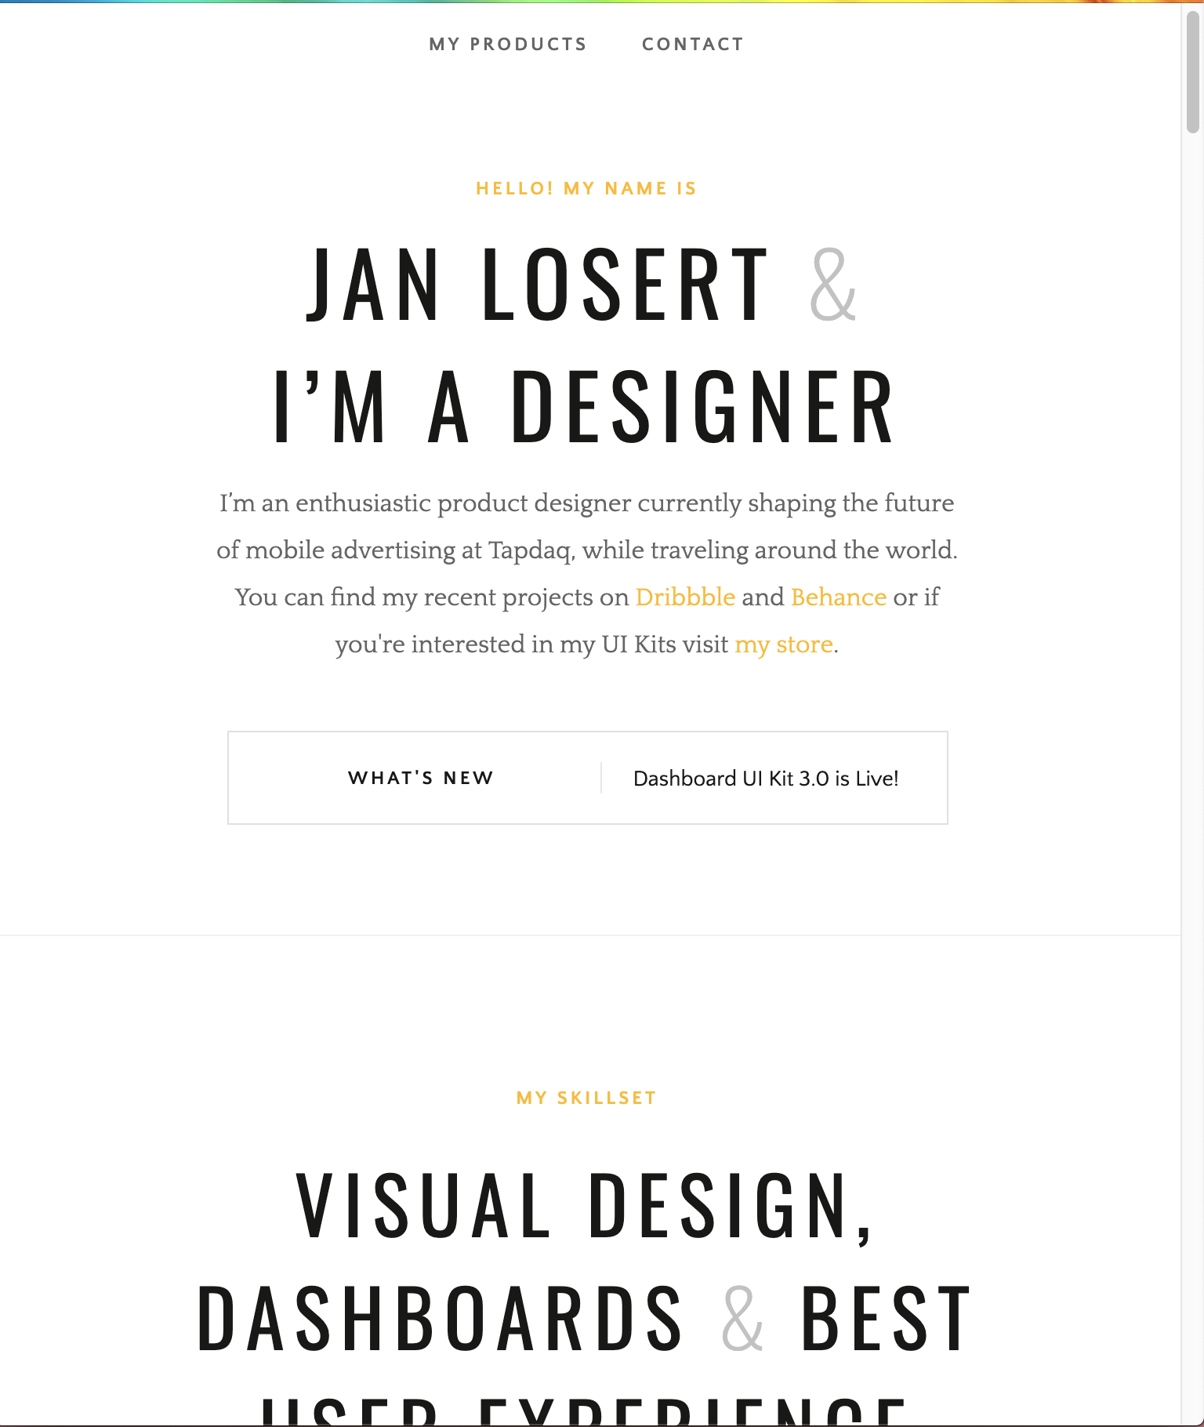

Portfolio 2:

<https://duhaihang.com/>

Features :A very dynamic page with an animated background. External links other pages with details of the many project worked on. List of awards at bottom of page

Layouts: Single page, that is has a scrollable list of past projects. Contact info listed at bottom of page. Section names are small and listed on the left side of screen

Styles: Minimalist , Dark background with white font.

Functionality: Verbiage on the page zooms out to you when you hover over it . Background can be distracting as impressive as it is.

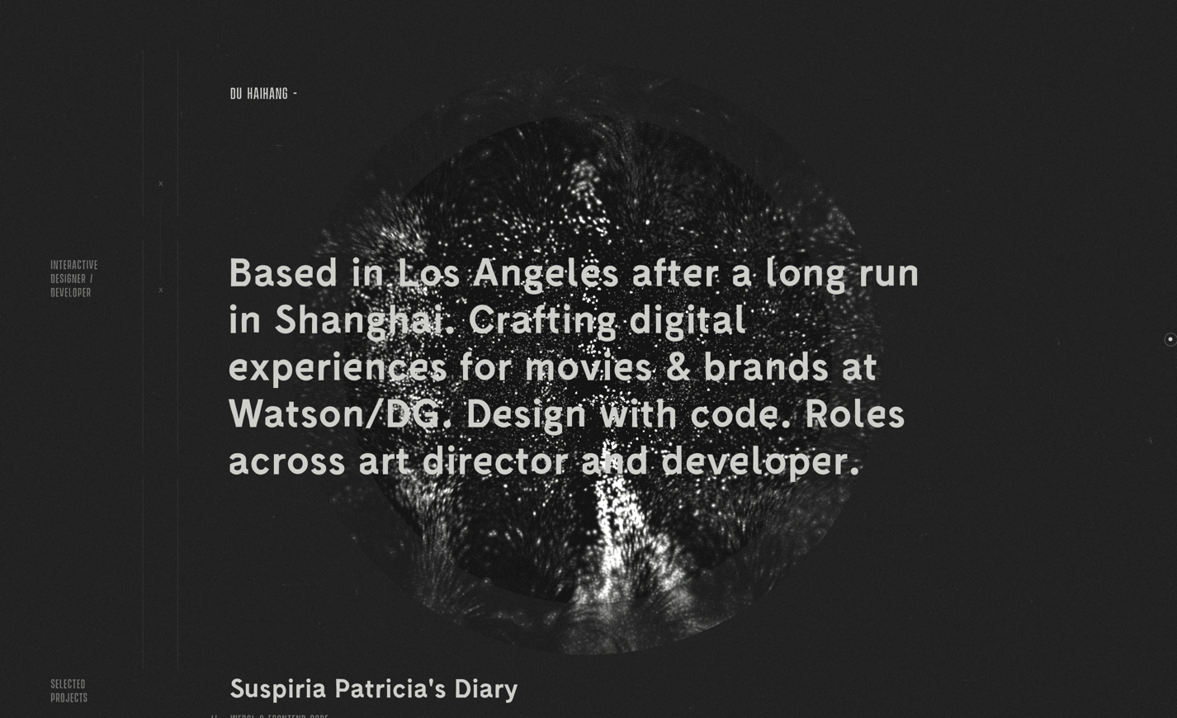

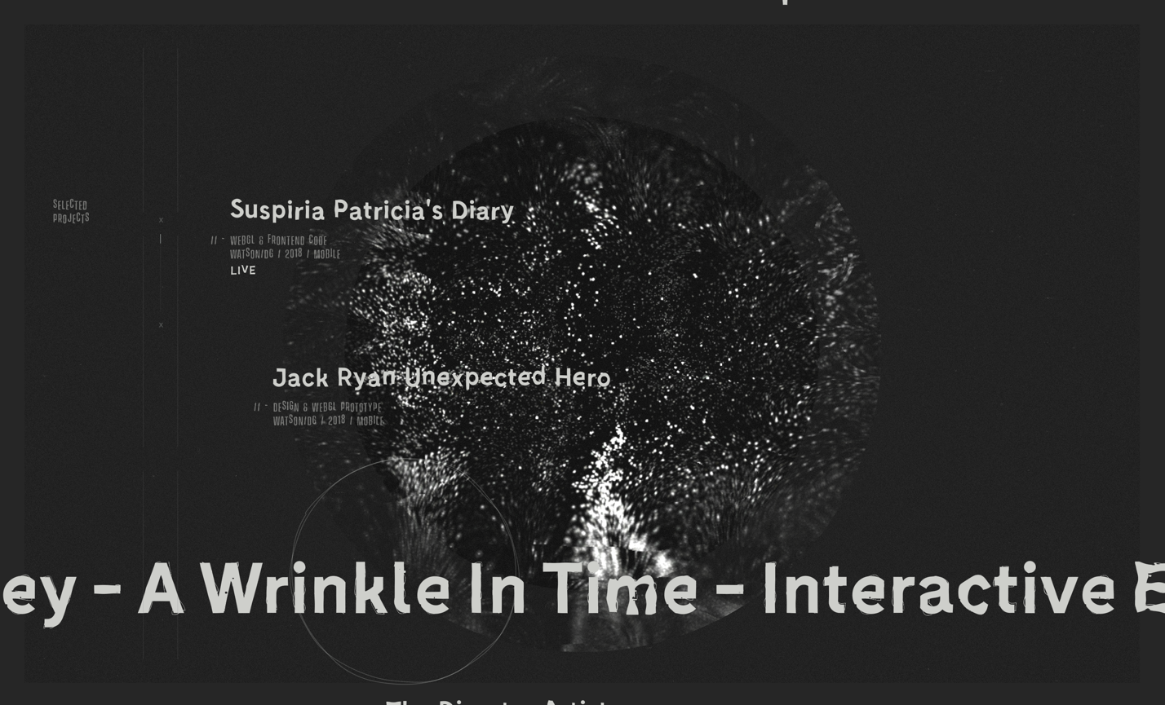

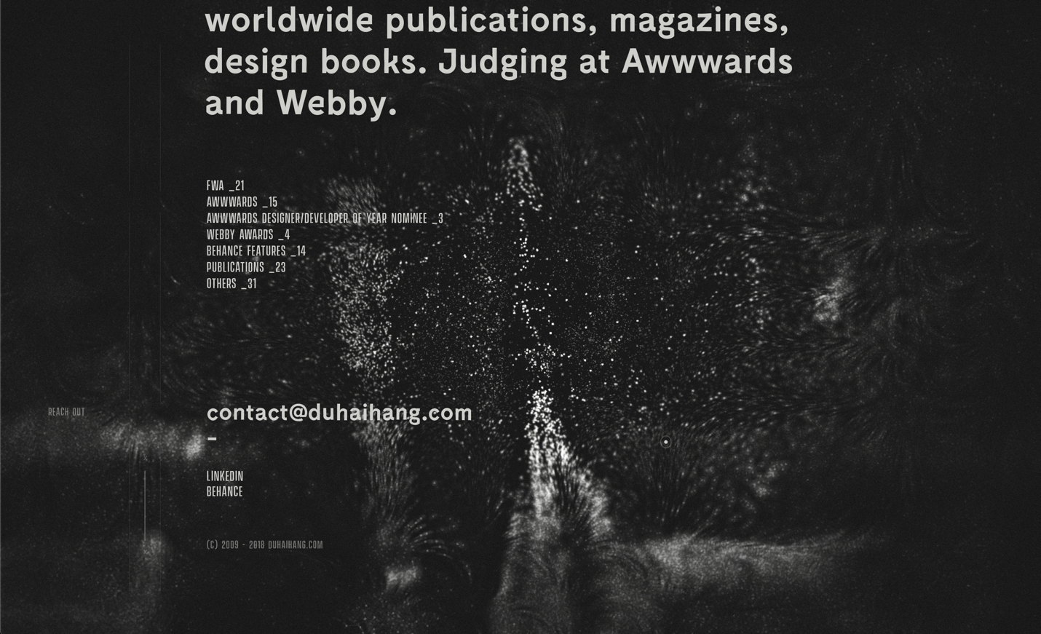

Portfolio 3: <https://nrly.co/>

Features: Another Dynamic page with a background that appears to be animated but less distracting.

Layouts: Several sections ( Intro, Selected Projects, About Me)

Styles: Simple fonts , abstract background. Two colors .

Functionality: clear indicator that tells you to scrolls for more information, A nice side bar that appears and appear when clicking the nav button. Very intuitive feel.

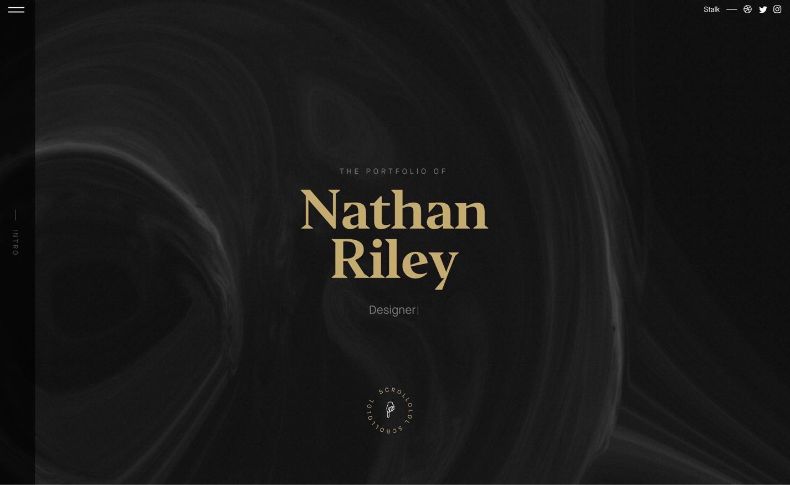

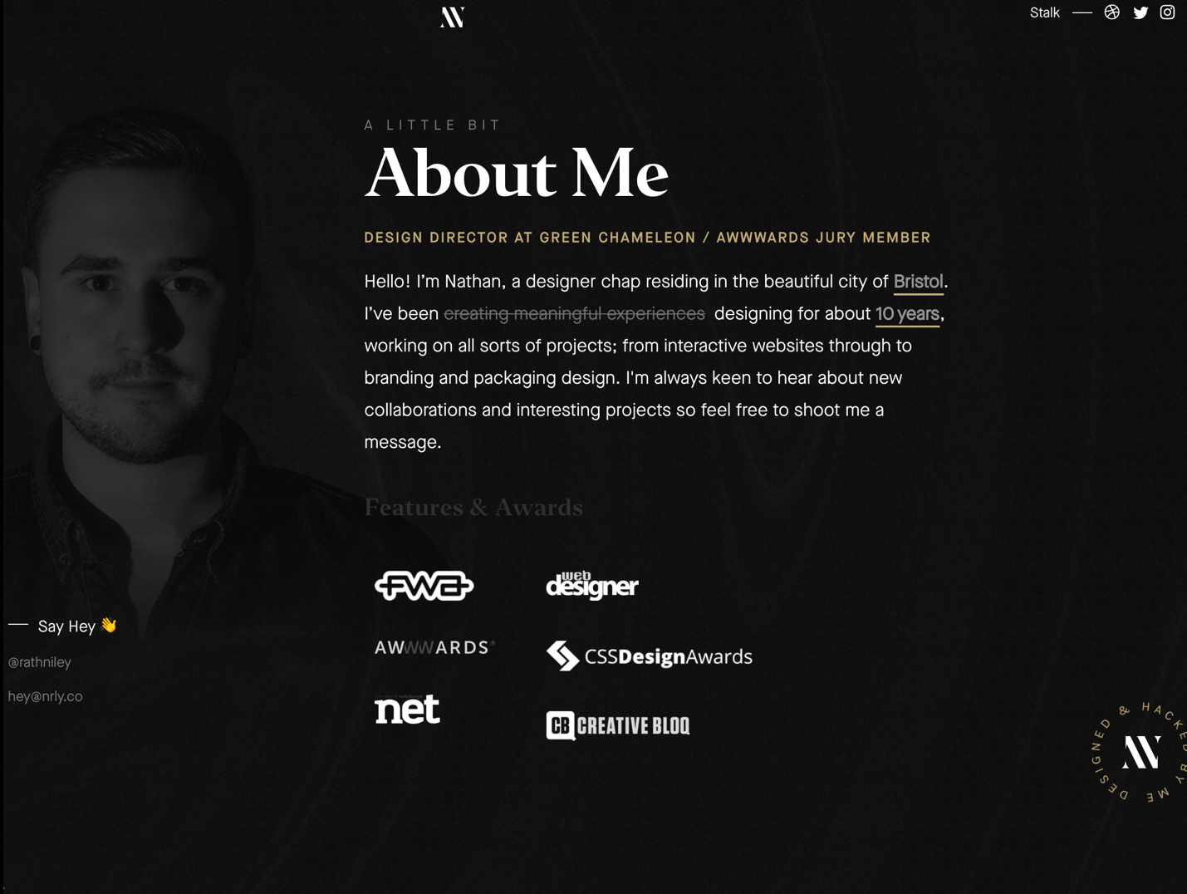

Random inspirations

